ASSINEMENT : MODULE END EVALUATION EXCEL
NAME : MOHAMMED FAZIL
BATCH : DAF69

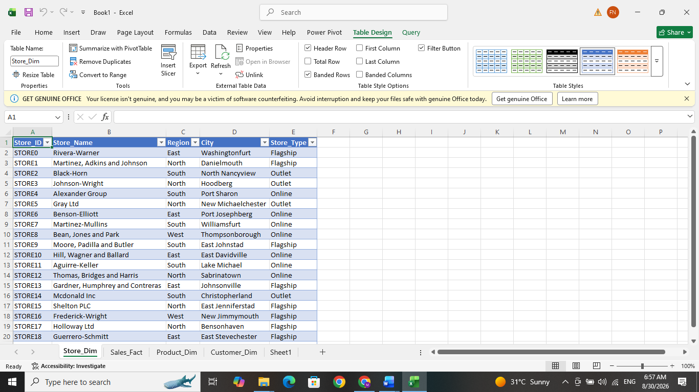
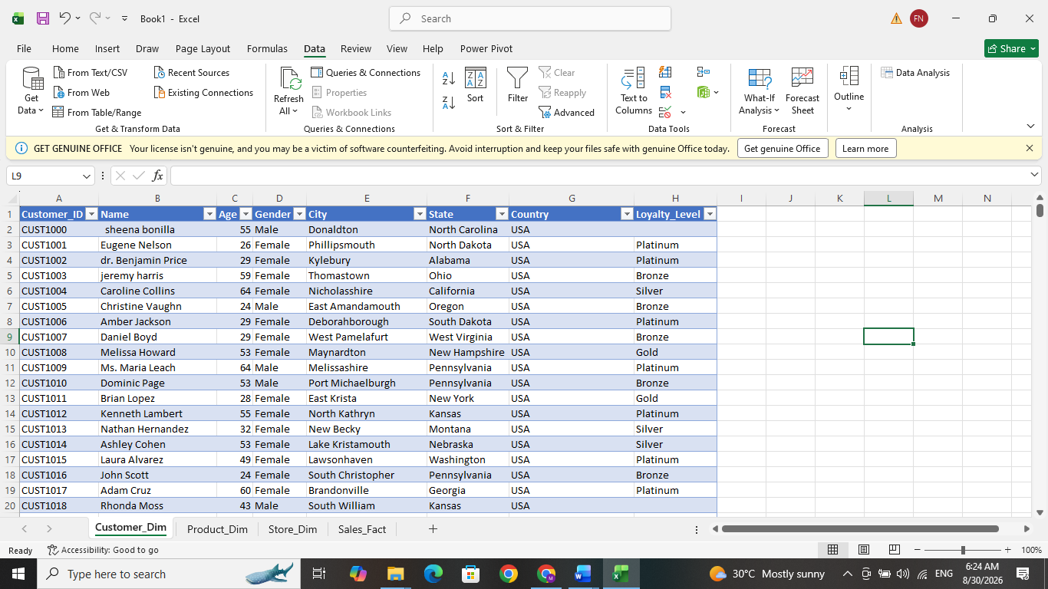
- Firstly, import the given raw dataset in excel through Data tab - Get-data and select the excel file. The given dataset is having 4 sheets named Customer_Dim ,Product_Dim, Store_Dim, Sales_Fact. These sheets are transformed into data which will get in the Power query editor. From there I just changed the headers of the Store_Dim by clickin ‘the first row as headers’ in the transform tab in the power query editor. Then all these sheets are load into the excel. These tables contain customer, product, store, and sales transaction information.

- Next, we are doing the Data cleaning step. First, we will check if the dataset has duplicates values. Confirmed that all the sheets in the dataset contain no duplicates.

In Sales_Fact, Customer_Dim & Product_Dim there are following missing values identified in the following column for the following data. This was identified by using the COUNTBLANK Function.
=COUNTBLANK(Sales_Fact[Quantity])
=COUNTBLANK(Sales_Fact[Unit_Price])
=COUNTBLANK(Sales_Fact[Discount])
=COUNTBLANK(Sales_Fact[Total_Amount])
=COUNTBLANK(Customer_Dim[Loyalty_Level])
=COUNTBLANK(Product_Dim[Cost])
=COUNTBLANK(Product_Dim[Stock])

Data table | Column | Missing Values
Product_Dim | Cost | 6
Product_Dim | Stock | 3
Sales_Fact | Quantity | 5
Sales_Fact | Unit_Price | 3
Sales_Fact | Discount | 4
Sales_Fact | Total_Amount | 4
Customer_Dim | Loyalty_Level | 4

We can handle the missing values by these methods:
In Customer_Dim, the missing values can be fill by MODE because it’s a categorical column.
Using COUNTIF function used to find the most repeated value. So I find out platinum was it, then fill it by platinum by using IF & ISBLANK function.
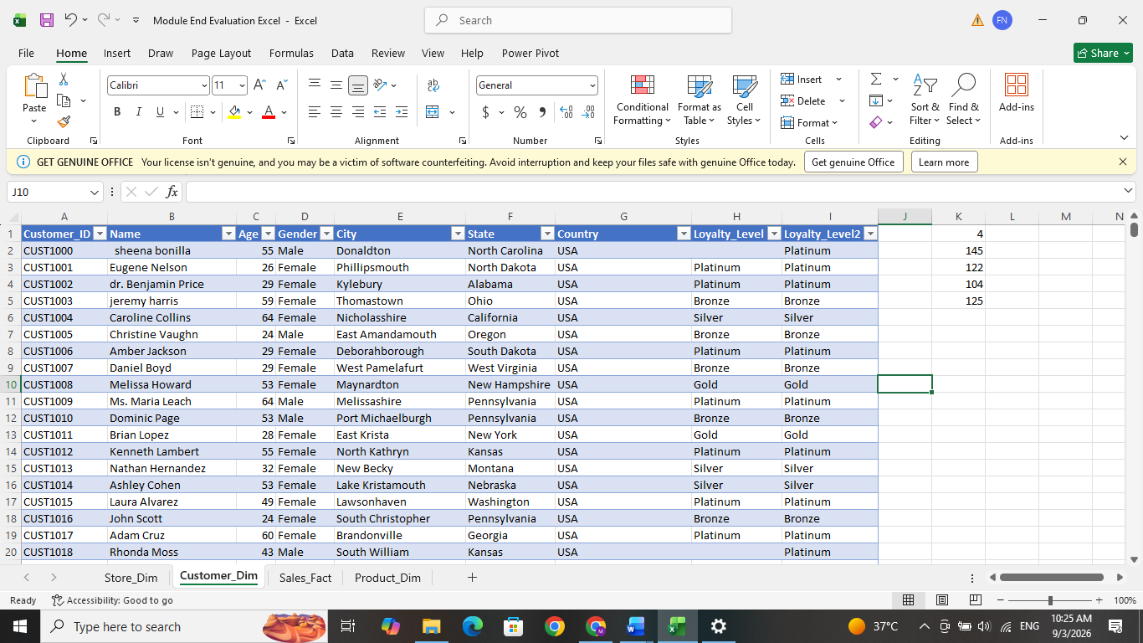
=IF(ISBLANK([@[Loyalty_Level]]),"Platinum",[@[Loyalty_Level]])
In Product_Dim,- Cost column and stock column missing value is filled by using median because it is generally better than mean when there may be unusually high or low product costs & high or low stock quantities i.e. extreme values have less influence. Here we use the IF and ISBLANK function. Median of cost is 242.965 and stock is 246
=IF(ISBLANK([@Cost]),MEDIAN([Cost]),[@Cost])
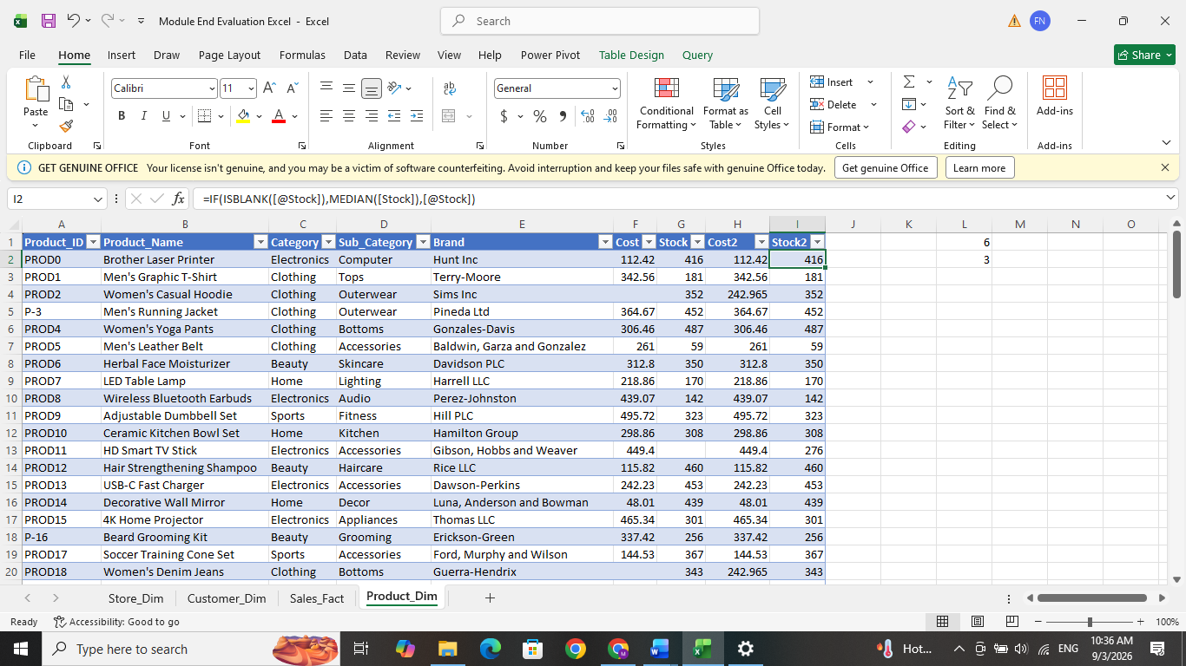
=IF(ISBLANK([@Stock]),MEDIAN([Stock]),[@Stock])

In Sales_Fact, the quantity, unit price & discount column we can fill empty cells with median.
Here which will be suitable because the numerical values and less affected by extreme values or outliers. As same as above, use IF & ISBLANK function fill up these empty cells.
=IF(ISBLANK([@Quantity]),MEDIAN([Quantity]),[@Quantity])
=IF(ISBLANK([@[Unit_Price]]),MEDIAN([Unit_Price]),[@[Unit_Price]])
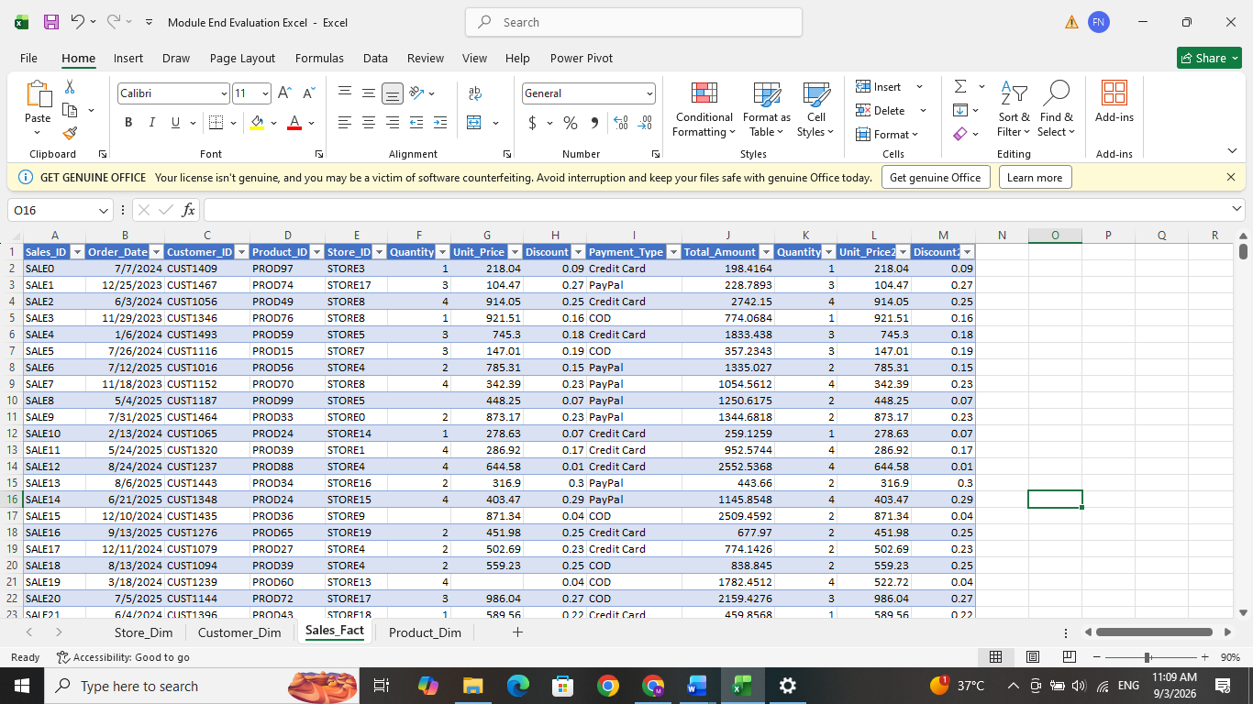
=IF(ISBLANK([@Discount]),MEDIAN([Discount]),[@Discount])
- In total amount column, the missing values cannot be fill by median or mean. Here we can use the formula to fill these empty cells. Already have fill the empty cells in quantity, unit price & Discount. We have to check how the total amount is calculated actually. So as per that we can fill the empty cells.
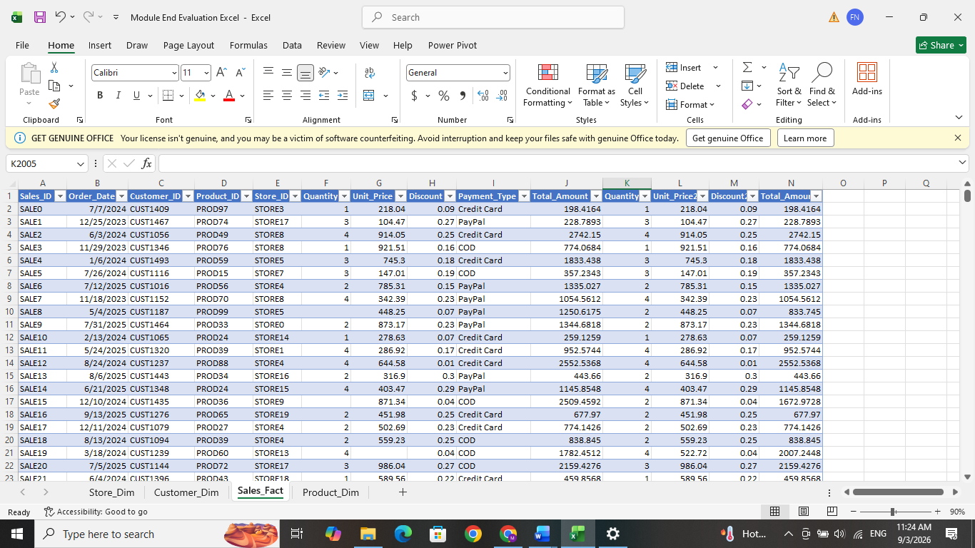
i.e., Total amount = Quantity x unit price x (1-discount)

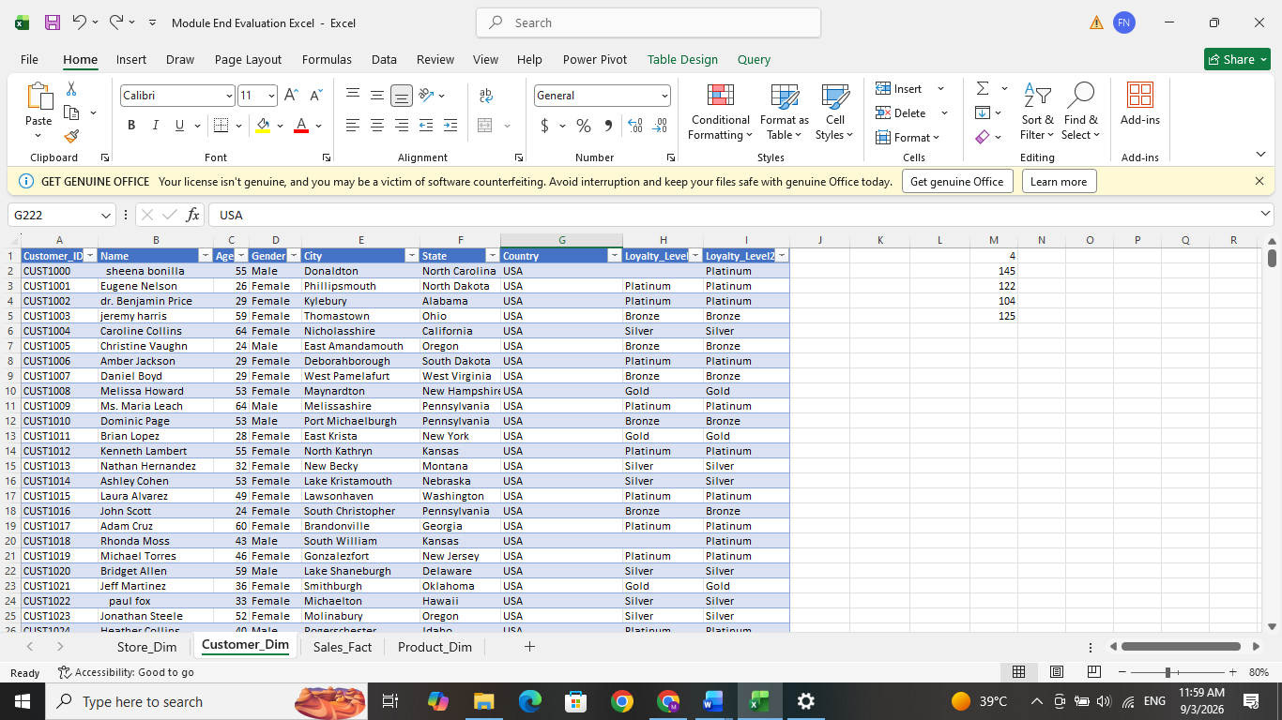
- Next, we checked for inconsistent data in the sheets. In the Customer_Dim sheet, the country USA was entered in two different formats “United States of America” and “USA.” Here we use the Find & Replace option to replace “United States of America” with “USA.” 3 replacement has done. And also identified the USA is in small letter format to make it Capitalization we can use find and replace again. 2 replacements have cleared. Next in the same table, Name and City has some extra spaces and also first letter is not capitilised, which is cleared by TRIM function and PROPER Function.
=PROPER(TRIM([@Name]))
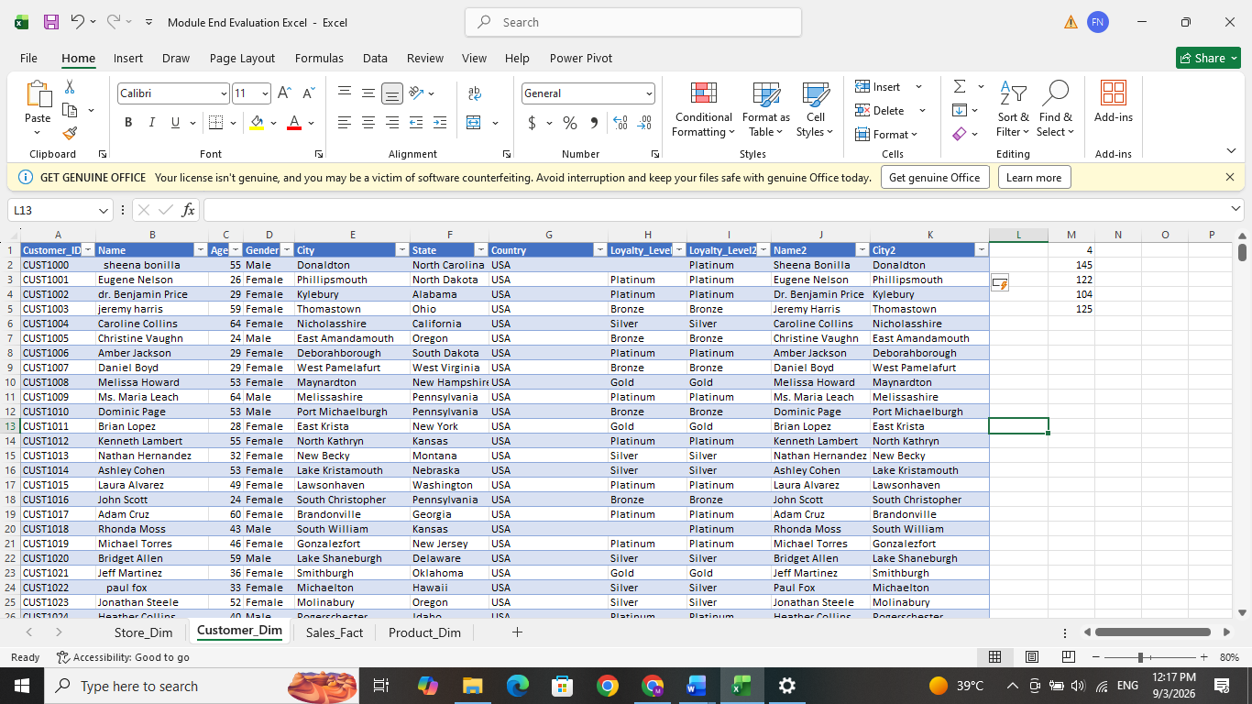
=PROPER(TRIM([@City]))

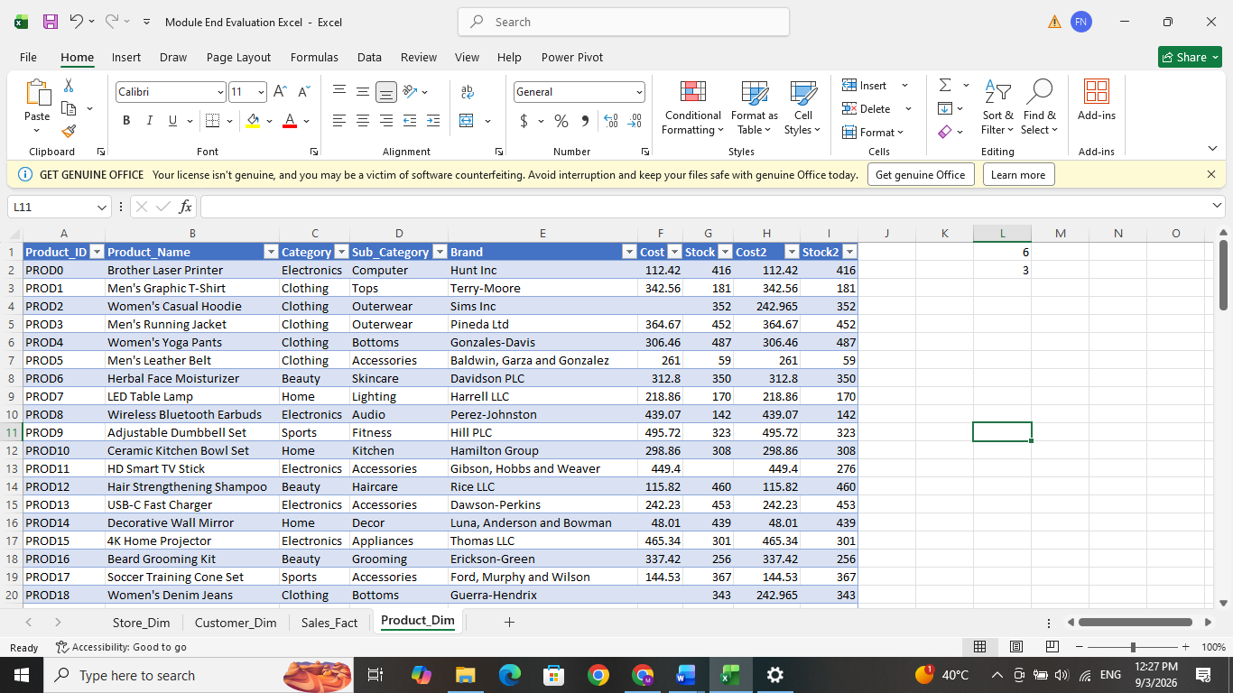
- In Product_Dim table, 2 items product id is different from the other format. P-3 & P-16 Which needs to be changed to PROD3 & PROD16 by find and replace method. Similarly, in the Customer_Dim table, the Customer IDs C-1464, C-1486, C-1491, and C-1499 were corrected to CUST1464, CUST1486, CUST1491, and CUST1499
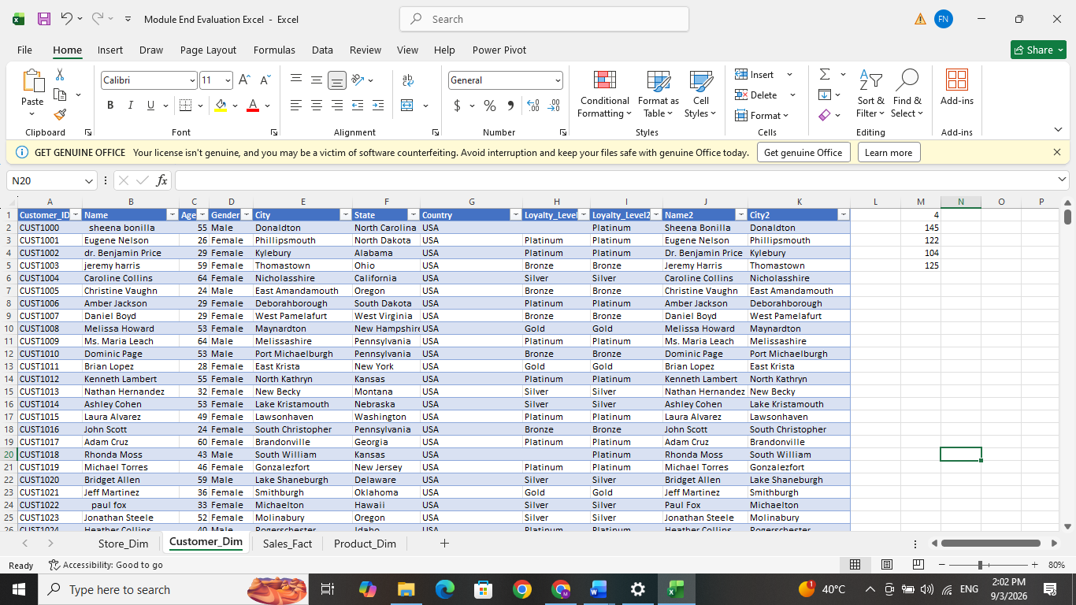
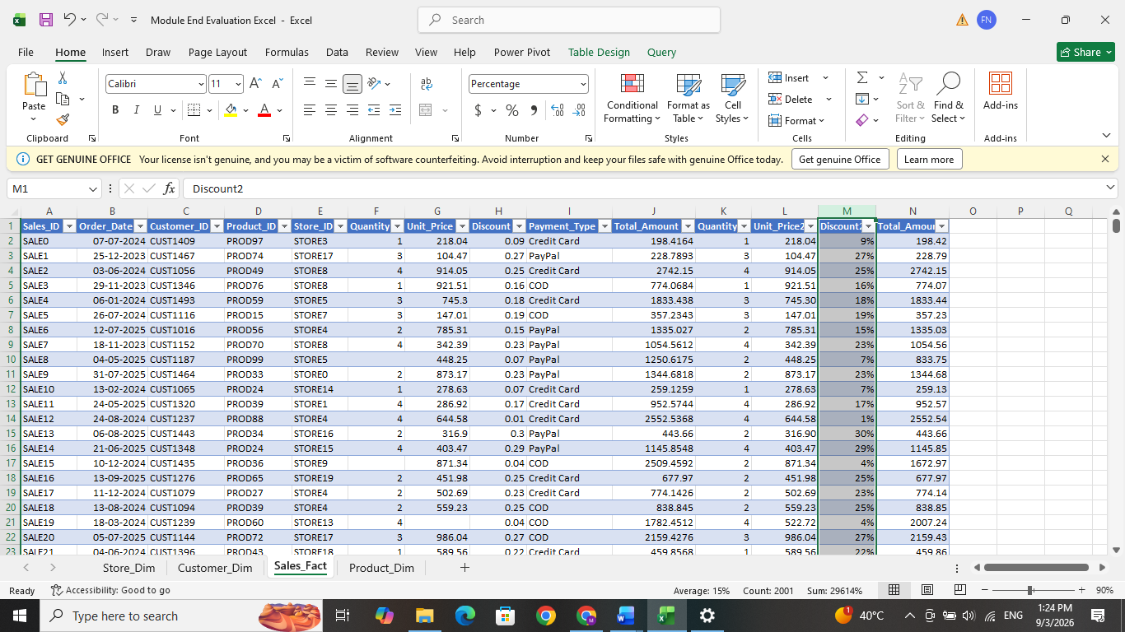
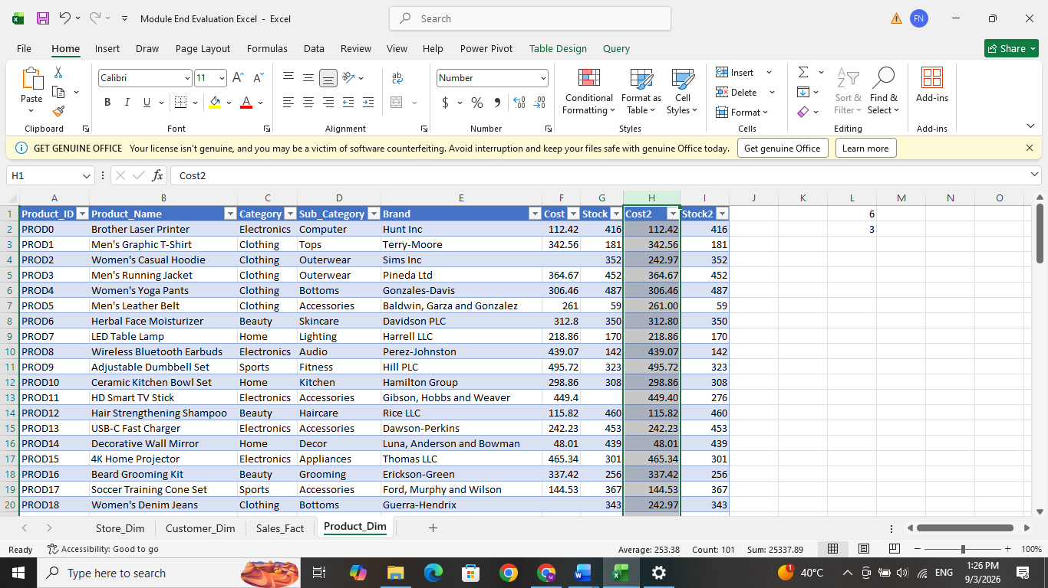
- In the Sales_Fact table, the Order Date column has inconsistent date formats. We can standardize it to DD-MM-YY using the Custom Number Format option. The Unit Price and Total Amount columns were changed from General to Number format, while the Discount column was changed to Percentage format. In the Product_Dim table, the Cost column was changed from General to Number format. The Stock column was also changed to Number format with zero decimal. As same as stock, the Age column was formatted as a whole number with no decimal places.
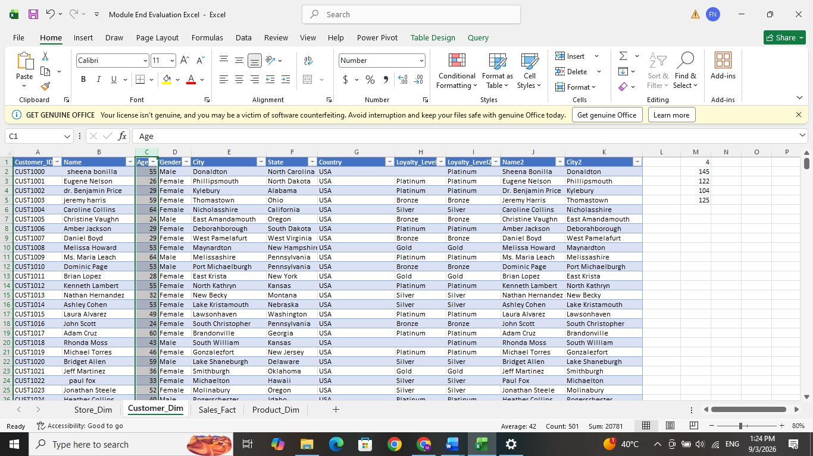

- The Sub_Category column was identified as irrelevant data as specified in the assignment requirement. It was removed from the Product_Dim table. Other original columns and helper columns were retained because they may be required for further analysis, lookup operations, PivotTables, and data visualization. For cleaned final dataset can be get from the LOOKUP DATA sheet.

- Here we can do some calculations for getting some findings. In the Sales_Fact table, Gross Amount represents the total sales value before applying the discount: Gross Amount = Quantity × Unit Price
The Discount Amount was then calculated as: Discount Amount = Gross Amount × Discount
In the Product_Dim table, Inventory Value was calculated to determine the total cost value of the available stock: Inventory Value = Stock × Cost

And also created a new sheet for the quick summary section using Excel functions to calculate some KPI. SUM was used to calculate total sales and total quantity sold, COUNTA was used to count the number of transactions, AVERAGE was used to find the average order value, and MIN and MAX were used to find the lowest and highest transaction values. SUMIF was used to calculate total sales for Credit Card, PayPal, and COD transactions. COUNTIF was used to determine the number of transactions made through each payment method, while AVERAGEIF was used to calculate the average transaction value for each payment type. This summary will give overall sales performance.
=SUM(Sales_Fact[Total_Amount2])
=SUM(Sales_Fact[Quantity2])
=COUNTA(Sales_Fact[Sales_ID])
=AVERAGE(Sales_Fact[Total_Amount])
=MIN(Sales_Fact[Total_Amount])
=MAX(Sales_Fact[Total_Amount])
=SUMIF(Sales_Fact[Payment_Type],"Credit Card",Sales_Fact[Total_Amount])
=SUMIF(Sales_Fact[Payment_Type],"PayPal",Sales_Fact[Total_Amount])
=SUMIF(Sales_Fact[Payment_Type],"COD",Sales_Fact[Total_Amount])
=COUNTIF(Sales_Fact[Payment_Type],"Credit Card")
=COUNTIF(Sales_Fact[Payment_Type],"PayPal")
=COUNTIF(Sales_Fact[Payment_Type],"COD")
=AVERAGEIF(Sales_Fact[Payment_Type],"Credit Card",Sales_Fact[Total_Amount])
=AVERAGEIF(Sales_Fact[Payment_Type],"PayPal",Sales_Fact[Total_Amount])
=AVERAGEIF(Sales_Fact[Payment_Type],"COD",Sales_Fact[Total_Amount])

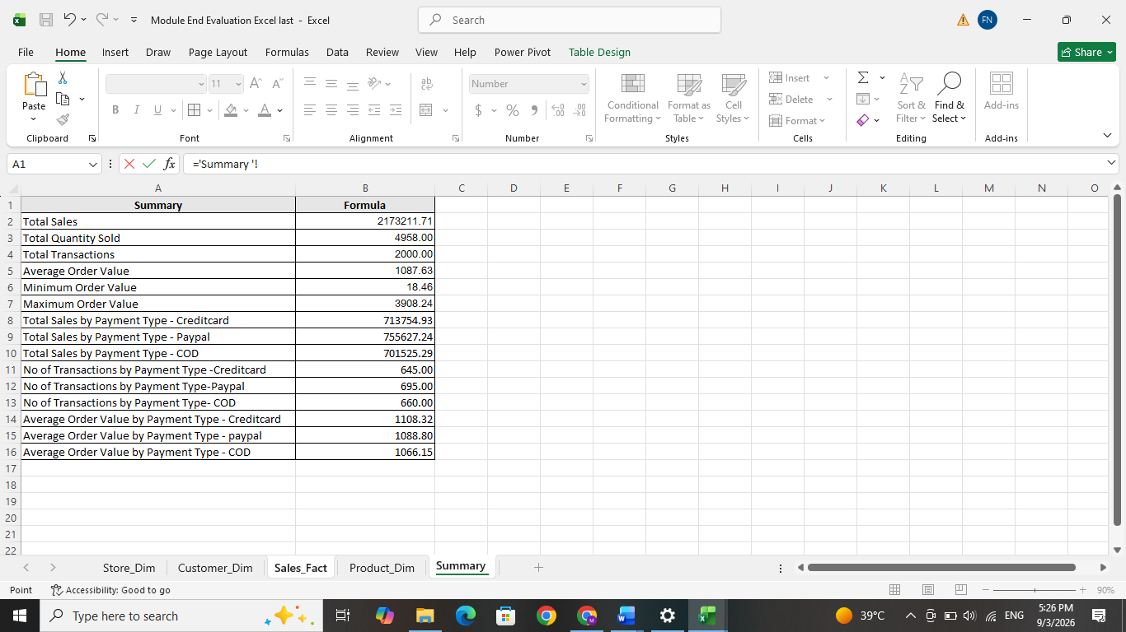

Here we can create a new column in the Sales_Fact table using the IF function. Orders with a Total amount greater than or equal to 1000 were named as “High Value”, while the remaining transactions were named as “Standard”. This helps segregate transactions based on their sales value.
=IF([@[Total_Amount2]]>1000,"High Value","Standard")

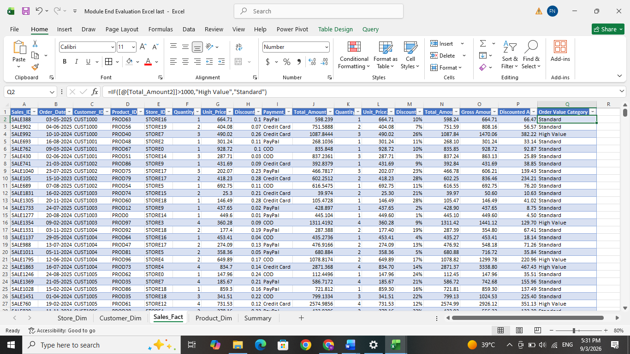

Stock Status column was created in the Product_Dim table using a Nested IF function. Products those stocks are below 100 can be named as “Low Stock”, stock between 100 and 299 as “Medium Stock”, and stock of 300 or more as “High Stock”. This will simply categorize and monitor inventory levels.
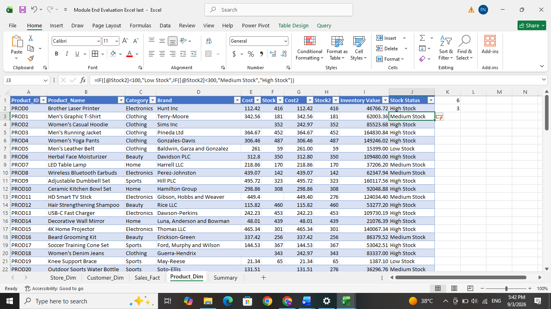
=IF([@Stock2]<100,"Low Stock",IF([@Stock2]<300,"Medium Stock","High Stock"))

Same as the stock we can do the ae grouping in the customer table. A column was created in the Customer_Dim table using a Nested IF function. Customers below 30 years were named as “Young”, customers aged 30 to 49 as “Middle Age”, and customers aged 50 and above as “Senior”.
=IF([@Age]<30,"Young",IF([@Age]<50,"Middle Age","Senior"))
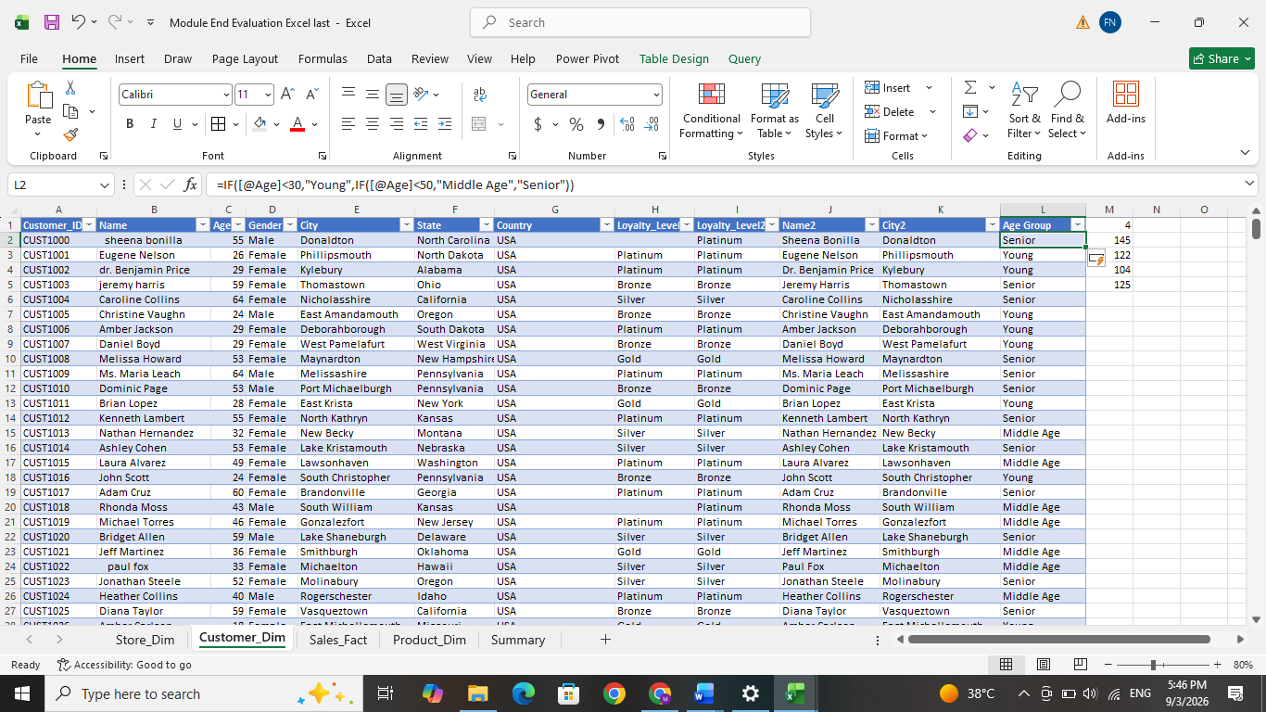
We can use the text operations using concatenation functions. The concatenation operator was used to combine Region and Store Type into a single descriptive field.
=[@Region]&" - "&[@[Store_Type]]
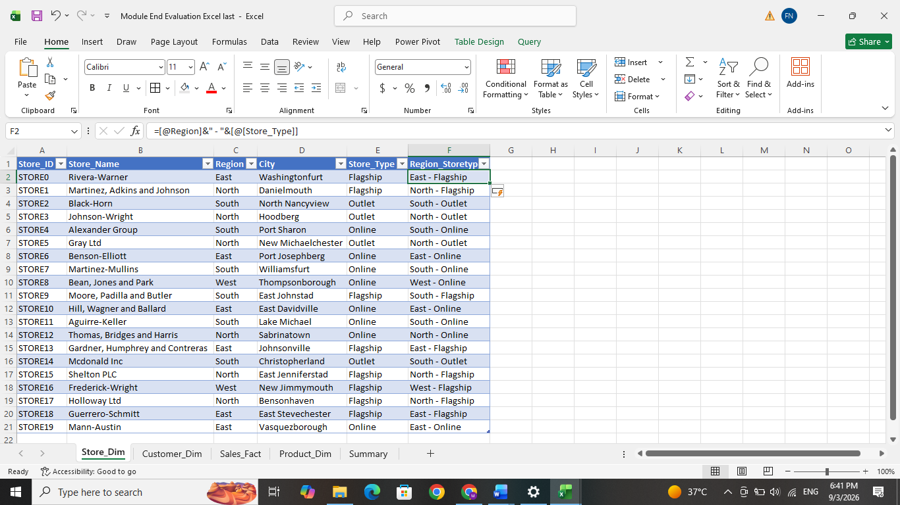
- Next, a separate LOOKUP DATA sheet was created using the cleaned Sales_Fact data as the main table. And then, the XLOOKUP function was used to combine required information from the Product_Dim, Customer_Dim, and Store_Dim tables through their common ID fields. Product_ID was used to fetch Product Name, Category, and Product Cost; Customer_ID was used to fetch Loyalty Level, Gender, and Age Group; and Store_ID was used to fetch Region and Store Type. Convert all the number format to currency format for better understanding and visualization. This created a cleaned new dataset which contain the all the information. this can be used for creating PivotTable analysis and data visualization. Also created a new column to find out the profit in the sales
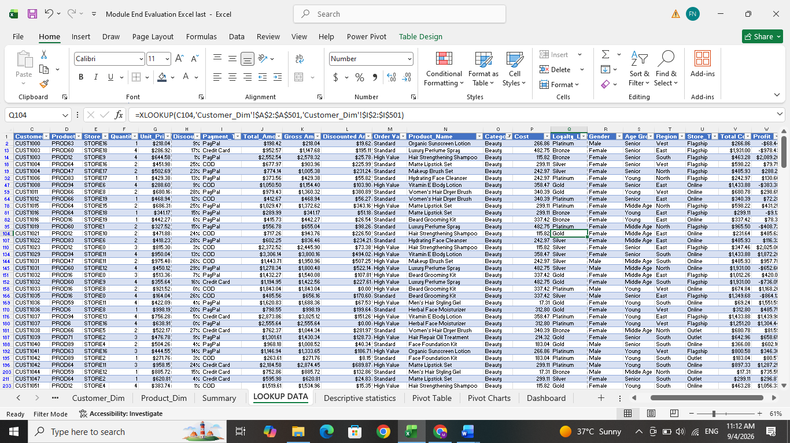
i.e Profit =[@[Total_Amount]]-[@[Total Cost]]
- Next to create the PivotTables using the LOOKUP DATA table to provide a visualization. The following tables is identified to get a clear insight about our data.
- Total sales were analyses by product category
- Total sales in different region to compare sales performance
- Payment Type and Loyalty Level summary by using both total sales amount and sales counts.
- Monthly sales trend pivot table was created by grouping order date into years and months
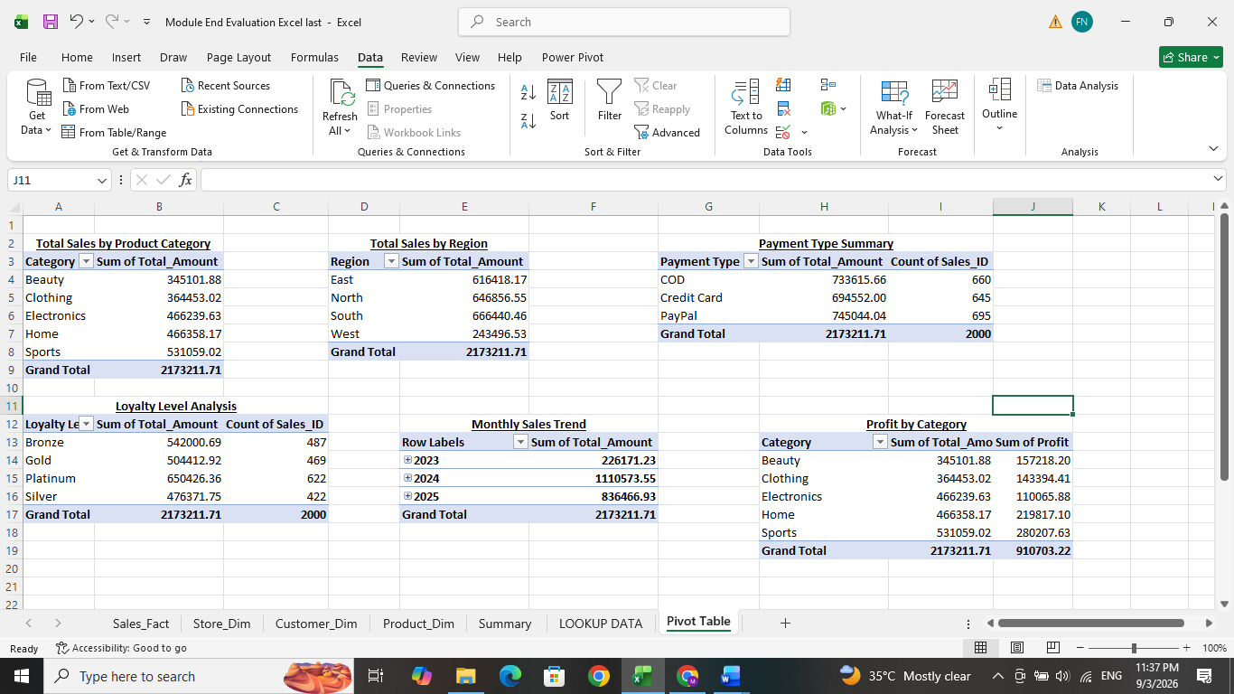
- Profit by category pivot table was created using Total Amount and Profit to compare the revenue and profit of each product category.

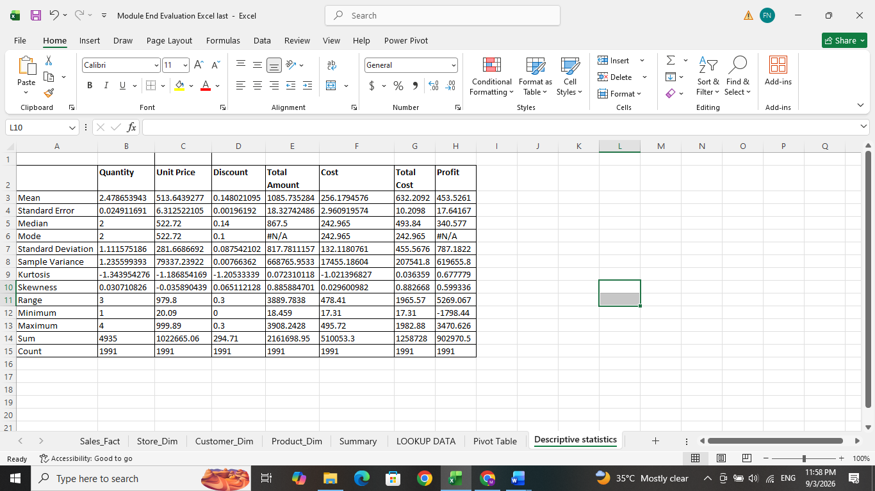
- Descriptive statistics can be displayed by data analysis in the data tab. From there select the data analysis option then select the required column select the range of input and output range. Then the mode median Standard deviation variance min max sum count etc. will be displayed. Here I displayed these columns statistics details – quantity, unit price, discount, total amount, cost, total cost ,profit.
- Next the Pivot charts were created using the pivot table to perform visualization part. A column chart was used to compare total sales by product category, a bar chart was used to compare regional sales performance, and a line chart was created to analyses monthly sales trends. Additional charts were created to compare profit by category and pie chart is added for payment-type transactions. Slicers were provided to provide interactive filtering of the PivotTables and Pivot Charts. Fields such as category, region, payment type, store type and loyalty Level were used as slicers. Report Connections were used to link each slicer to multiple Pivotable. And a Timeline was also added using the Order Date field to allow users to filter by year, quarter, month, or day.

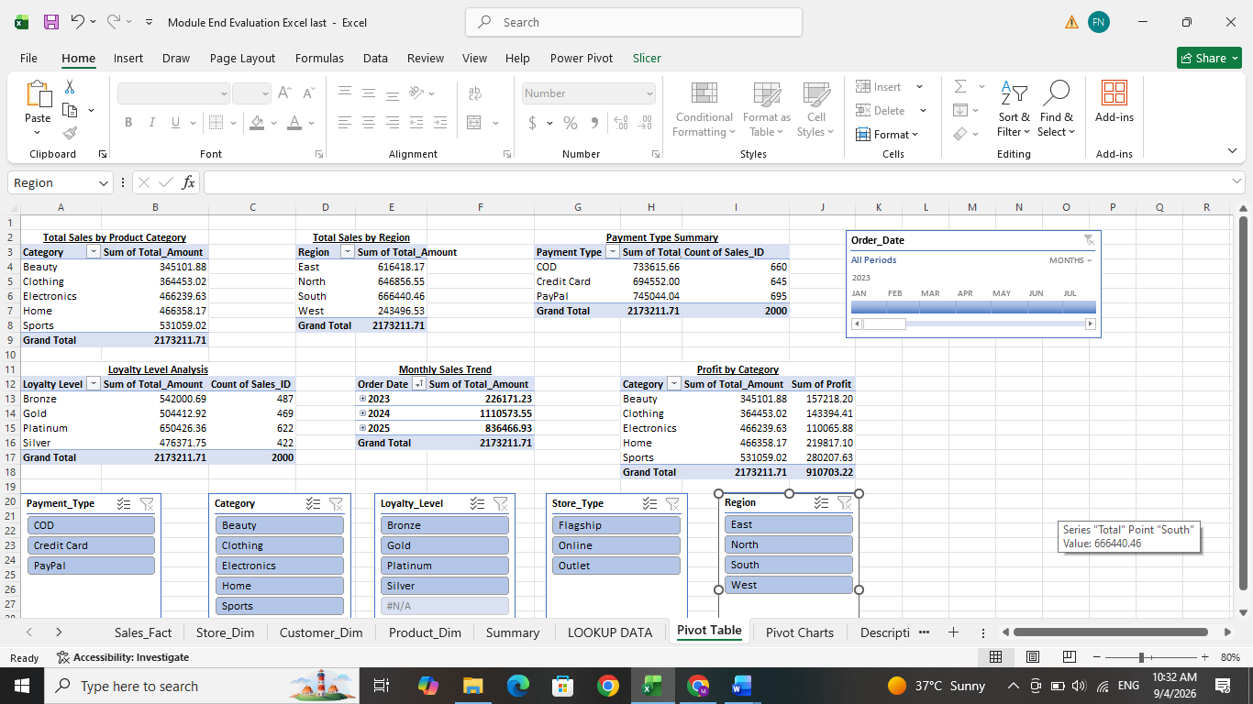
- Finally we created an interactive Dashboard for the E-Commerce sales. The dashboard has 6 KPI - Total Sales, Total Quantity Sold, Total Transactions, Average Order Value, Min order value, Max order value. These provide a quick summary of the overall sales performance. And the following pivot chart is provided.
- Sales and Profit by Category – Clustered Column Chart
- Sales by Region – Bar Chart
- Monthly Sales Trend – Line Chart
- Payment Type Summary – Pie/Doughnut Chart
To make the dashboard interactive, slicers and timeline were added for Category, Region, Payment Type, Loyalty Level, and Store Type & Order Date.

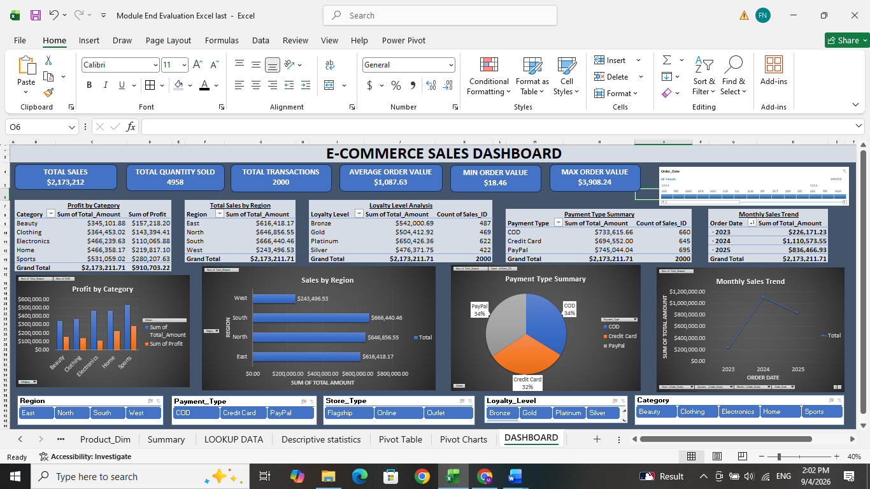
INSIGHTS & DESCISIONS:

The interactive E-commerce dashboard provides an overall view of sales, profitability, customer behavior, region wise performance, payment methods, and sales trends. The given dataset contains 2000 sales transactions with 4958 quantity of items has sold and total sales of approximately 2.1 million. From this dashboard we can dynamically filter the results using Category, Region, Payment Type, Loyalty Level, Store Type, and Order Date.
Main insights we got it form the dataset is that as follows :
- In the product Category, the sports generated the highest sales at approximately $531059 and also produced the highest profit of approximately $280208. This means its the best performing category. So focusing more on sports category to get more sales.
- Home and Electronics shows similar sales of around $466000, but Home produced higher profit than Electronics. Electronics had the lowest category profit at approximately $110066.
- When we check in Regional wise performance, the South region gives the highest sales at approximately $666440, North at $646857 and East at $616418. The West region had lower sales at approximately $243497. That means west region area requires improvement. Most customers from the south. So, keep strengthening the south area by different strategy. And Also give promotions, customer review survey, offers or check the demand items or price variations in west region to get know the problem facing for the lower sales.
- In the different payment modes, PayPal generated the highest sales at approximately $745044 and also had the highest number of transactions with 695 orders. COD is with approximately $733616 from 660 transactions, while Credit Card gives approximately $694552 from 645 transactions. i.e. PayPal is the most frequently used payment method and also gives the highest sales among other payment methods. So continue promote and support PayPal payment customers and tis method
- In the Customer Loyalty, Platinum customers make the highest sales at approximately $650426 and also had the highest transaction count with 622 transactions. This means that the Platinum customers are an important customer to the organization. For sustain these customers, attract new customers and improve more sales, give a special treatment to the platinum customers like discounts, special early offers, rewards.
- By checking the Sales Trend, 2024 year is the highest sales at approximately $1.11million and the 2025 year at approximately $836467 and 2023 year is at approximately $226171.
- Overall profit of the company is approximately $910703, which is about 41.9% of total sales. Sports is the most profitable category. Electronics shows relatively high sales but comparatively lower profit. That means electronics has lower profit margin. So review the electronics items sales and increase its profit margin to get more profit.
- Reduce the discount for some items like electronics because they already has low margin and low profits.

